**Lab 10: Android Styles**

# **Introduction**

A style resource establishes a UI's format and appearance. A view can have a style applied to it from within a layout file, and an activity or an entire application can also have a style applied (from within the manifest file).

**Let’s get Started**

This exercise will take you through simple steps to show how to create your own Android application using Style.

**Step 1: Create a New Project in Android Studio as shown below**

**Step 2: Select Empty Activity as shown below**

**Step 3: Provide a Project Name as shown below**

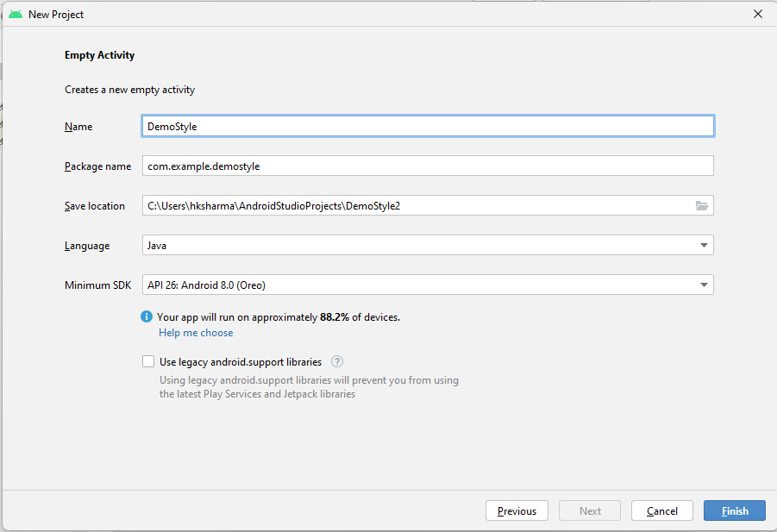

**Step 4: Update MainActivity.java as per the code given below**

**package** com.example.demoStyle;  
**import** androidx.appcompat.app.AppCompatActivity;  
**import** android.os.Bundle;  
**public class** MainActivity **extends** AppCompatActivity {  
  
 @Override  
 **protected void** onCreate(Bundle savedInstanceState) {  
 **super**.onCreate(savedInstanceState);  
 setContentView(R.layout.***activity_main***);  
 }  
}

**Step 5: Create a new xml file style.xml in res/values folder and write the code given below**

*<?***xml version="1.0" encoding="utf-8"***?>*<**resources**>  
 <**style name="btnStyle"**>  
 <**item name="android:textSize"**>30dp</**item**>  
 <**item name="android:textColor"**>#fff</**item**>  
 <**item name="android:backgroundTint"**>#D32F2F</**item**>  
 <**item name="android:layout_width"**>fill_parent</**item**>  
 <**item name="android:layout_height"**>wrap_content</**item**>  
 </**style**>  
</**resources**>

**Step 6: Update activity_main.xml as per the code given below**

*<?***xml version="1.0" encoding="utf-8"***?>*<**LinearLayout  
 xmlns:android="http://schemas.android.com/apk/res/android"  
 xmlns:app="http://schemas.android.com/apk/res-auto"  
 xmlns:tools="http://schemas.android.com/tools"  
 android:layout_width="match_parent"  
 android:layout_height="match_parent"  
 android:orientation="vertical"  
 tools:context=".MainActivity"**>  
 <**Button  
 style="@style/btnStyle"  
 android:text="Android"**/>  
 <**Button  
 style="@style/btnStyle"  
 android:text="Windows"**/>  
 <**Button  
 style="@style/btnStyle"  
 android:text="iPhone"**/>  
 <**Button  
 style="@style/btnStyle"  
 android:text="Blackberry"**/>  
 <**Button  
 style="@style/btnStyle"  
 android:text="Nokia"**/>  
</**LinearLayout**>

**Step 7: Check Output on Android Emulator.**

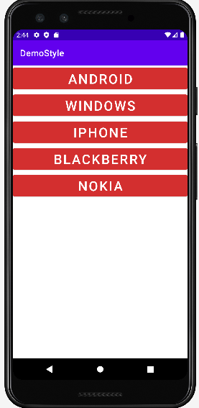

**Step 8: Update style.xml as the code given below**

*<?***xml version="1.0" encoding="utf-8"***?>*<**resources**>  
 <**style name="btnStyle"**>  
 <**item name="android:textSize"**>30dp</**item**>  
 <**item name="android:textColor"**>#FB0606</**item**>  
 <**item name="android:backgroundTint"**>#FBC02D</**item**>  
 <**item name="android:layout_width"**>fill_parent</**item**>  
 <**item name="android:layout_height"**>wrap_content</**item**>  
 </**style**>  
</**resources**>

**Step 9: Check Output on Android Emulator.**

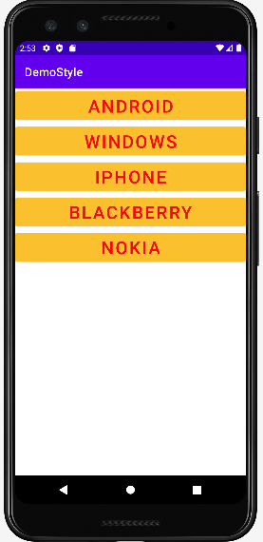

**Voila!!** We have successfully completed this lab.